HOME NON-INVASIVE BLOOD PRESSURE (NIBP) MONITOR
Detailed Software Design

Introduction
This document contains the detailed software design of the blood pressure monitor.

State Implementations
SoftwareReq1: Initialize
 | Hardware | Software
Inputs | None | None
Outputs | None | None

Description: This state initializes the device after power on and initializes the hardware peripherals. These include the display, the digital I/O, and the analog input.
[Covers: SystemReq1]

SoftwareReq2: Idle
 | Hardware | Software
Inputs | Button | None
Outputs | None | None

Description: This state monitors the button to see if it is pressed. Also, it powers off the device if it’s on too long.
[Covers: SystemReq11]

SoftwareReq3: Inflate
 | Hardware | Software
Inputs | Button, Pressure | None
Outputs | Valve, Pump | None

Description: This state inflates the cuff monitoring to make sure that the cuff is on the patient and that the user has not aborted the process.
[Covers: SystemReq9] [Covers: SystemReq10] [Covers: SystemReq11] [Covers: SystemReq12]

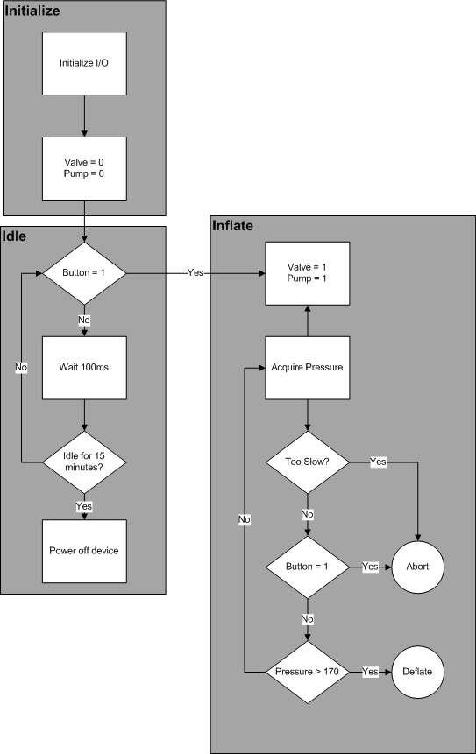
SoftwareReq4: Deflate
 | Hardware | Software
Inputs | Button, Pressure | None
Outputs | Valve, Pump | None

Description: This state allows the device to deflate naturally, and as it deflates, it acquires the pressure sensor data. It also monitors to ensure that the user has not aborted the measurelkasdjflkadsjfament.
[Covers: SystemReq4] [Covers: SystemReq9] [Covers: SystemReq10] [Covers: SystemReq11] [Covers: SystemReq12]

SoftwareReq5: Analyze
 | Hardware | Software
Inputs | None | Raw Pressure Data
Outputs | Speaker | Pressure Vector, Amplitude Vector, Heart Rate Vector

Description: This state analyzes the pressure data to determine the heart rate and builds up the amplitude and pressure vectors that are used to determine the mean arterial pressure.
[Covers: SystemReq4] [Covers: SystemReq5] [Covers: SystemReq6] [Covers: SystemReq7] [Covers: SystemReq8]
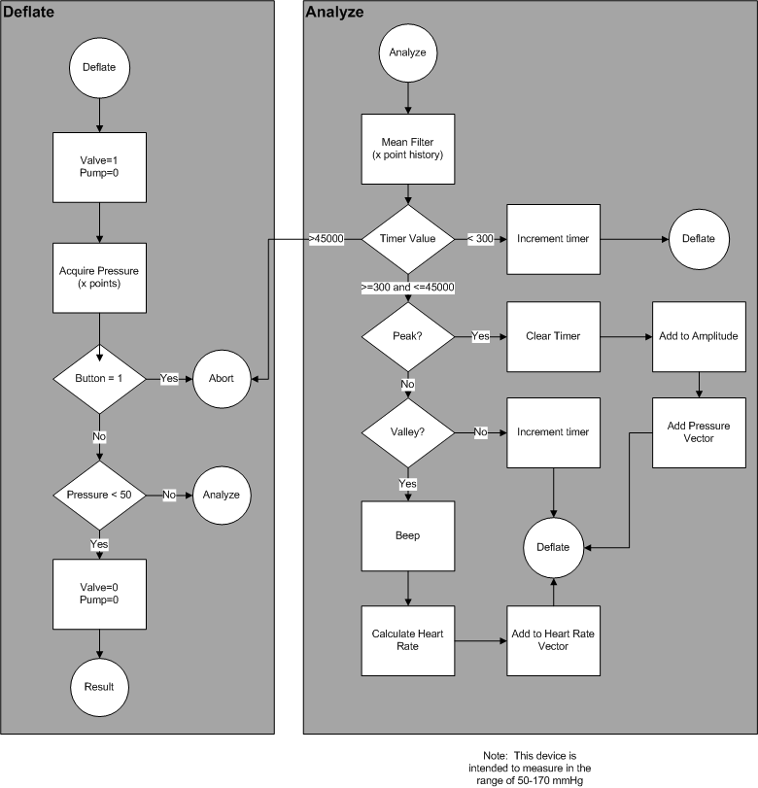

SoftwareReq6: Result
 | Hardware | Software
Inputs | None | Pressure Vector, Amplitude Vector, Heart Rate Vector
Outputs | Display | None

Description: This state calculates average heart rate, the systolic blood pressure, and the diastolic blood pressure and displays them.
[Covers: SystemReq4] [Covers: SystemReq5] [Covers: SystemReq6] [Covers: SystemReq7] [Covers: SystemReq8]

SoftwareReq7: Abort
 | Hardware | Software
Inputs | None | None
Outputs | Display, Pump, Valve | None

Description: This is the case that ends the measurement and returns the pump to idle. If this state is executed, the user aborted the measurement or an error occurred.
[Covers: SystemReq9] [Covers: SystemReq10] [Covers: SystemReq11] [Covers: SystemReq12]

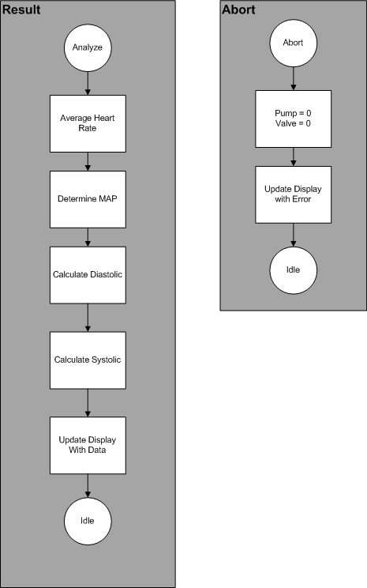
SoftwareReq8: Main
 | Hardware | Software
Inputs | Pressure, Button | None
Outputs | Display, Pump, Valve, Beep | None

Description: This is the main program responsible for managing the user interface, all physical inputs and outputs.
[Covers: SystemReq1] [Covers: SystemReq2] [Covers: SystemReq3]

Variable Types

 | Name | Type | Attributes
Software | Pressure Vector | 1D Array – I32
 | Amplitude Vector | 1D Array – I32
 | Heart Rate Vector | 1D Array – I32
 | Analyze Timer | I32
 | Idle Timer | I32
Hardware Inputs | Button | Boolean | Digital Input
 | Pressure | I32 | Analog Input
Hardware Outputs | Display | String | 3 Lines 8 Char
 | Valve | Boolean | Digital Output
 | Pump | Boolean | Digital Output
 | Beep | Boolean | PWM Output

Algorithm Requirements
AlgorithmReq1: Blood Pressure Calculation
Description: This function shall compute the mean heart rate, systolic pressure and diastolic pressure based upon the specified inputs:
- Heart Rates: Array of doubles representing the number of beats per minute over the period of time the measurements were acquired
- Peak Pressures: Array of double representing peak pressures representing the amount of pressure at the peak of the measurement for each heart beat over the period of time the measurements were acquired
- Peak Amplitudes: Array of corresponding amplitudes of the pressures, which is the value relative to the absolute minimum pressure during the period between an individual heart beat.
The algorithm for this function will filter outliers beyond a certain range, and compute the diastolic and systolic pressure by identifying the amplitude of the largest peak.
[Covers: SystemReq1] [Covers: SystemReq2]
AlgorithmReq2: Filter Outliers
The algorithm for this function will filter outliers beyond a certain range, and compute the diastolic and systolic pressure by identifying the amplitude of the largest peak.
[Covers: SystemReq1] [Covers: SystemReq2]

GUI Component Requirements
UIReq1: Blood Pressure Graph over time
Description: The UI shall include a graph displaying the patient’s pressure over time during the inflation and deflation process
[Covers: SystemReq3]
UIReq2: BPM Indicator
Description: The UI shall include a chart showing the patient’s pulse over time
[Covers: SystemReq3]
UIReq3: BPM LED Indicator
Description: The UI shall include a light that flashes to coincide with pulses
[Covers: SystemReq3]
UIReq4: Instantaneous BPM Number
Description: The UI shall include a numerical display during acquisition that shows the instantaneous beats per minute
[Covers: SystemReq3]
UIReq5: Diastolic Pressure
Description: The UI shall include a numerical display where the diastolic pressure is shown to three decimal places
[Covers: SystemReq3]
UIReq6: Systolic Pressure
Description: The UI shall include a numerical display where the systolic pressure is shown to three decimal places
[Covers: SystemReq3]
UIReq7: Average Heart Rate
Description: The UI shall include a numerical display that shows the average heart rate of the patient during the acquisition of the data
[Covers: SystemReq3]

